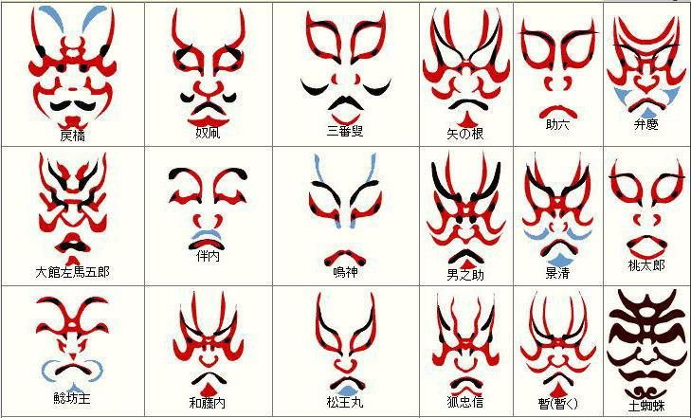
Examples of Kabuki Make-Up
For supernatural heroes and villains, which appear frequently in Kabuki plays, there is a special style of makeup called kumadori. Kumadori is made up of dramatic lines and shapes applied in different colors, each representing different qualities.

Kabuki Colors and Meanings
- Deep Red- anger, forcefulness
- Red- passion, eagerness
- Pink- youthfulness
- Light Blue- calmness, coolness
- Indigo- melancholy
- Light Green- Tranquility
- Purple- nobility, loftiness
- Brown- selfishness
- Gray on chin- dreariness, cheerlessness
- Black- fear, terror, gloom

